Acceleration Investigation
Aim: To investigate the relationship between force and acceleration.
Equipment Per Group | Method | Notes and guidance
- Wheeled trolley  - Metre ruler  - Pencil, chalk or masking tape to mark the intervals  - Bench pulley  - String  - Slotted masses (1N)  - Stopwatch (with ‘laps’ function)  - Blu-tac. | - Using the metre ruler, measure 20cm intervals on the bench and mark these.  - Fix the pulley to the bench. Test it to ensure it is secure.  - Tie one end of a length of string to the wheeled trolley and the other to the slotted masses (1N).  - Position the trolley at the end of the bench start point facing the pulley and hold onto it.  - Stretch the length of string over the pulley so the slotted masses are dangling freely.  - Simultaneously release the trolley and start the stopwatch.  - Press the stopwatch to record a new lap as the trolley passes each interval.  - Retrieve the slotted masses from the floor.  - Record the results on your table.  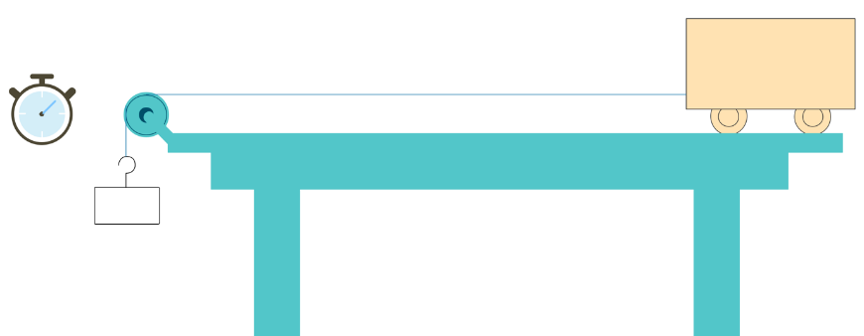  - Remove some slotted masses and repeat the experiment. | The trolley’s acceleration should be kept as low as possible by selecting an appropriate trolley/slotted masses combination. Some testing will be required.  This principle of acceleration can be demonstrated with many different types of equipment. If you have light-gates and data-logging software available, they will provide much more reliable results. If you can carry out the experiment with frictionless air-tracks, even better.  Depending on your department’s budget, there may be limitations on the number of sets of equipment that can be provided. It could be worth considering a class demo with light-gates and data-loggers if possible.  Results table:
   | 1N | 0.8N | 0.6N | 0.4N | 0.2N
  Distance (cm) | Time in s | Time in s | Time in s | Time in s | Time in s
  20
  40
  60
  80
  100
General Teacher Notes
A risk assessment must be completed for this practical. The risk assessment should be specific to the class involved and written only by the teaching member of staff. For more guidance refer to CLEAPSS.
Clearing up
It is important that equipment is returned to the prep room in good order. Return everything back to the tray it came in neatly.
If the trays arrived on a trolley, students must return all trays and equipment to that trolley.

Technician Notes | Hazcards | Clearing away
The way this experiment is carried out depends on what equipment is available. Discuss this with the teacher beforehand. It is always worth testing the experiment to ensure reliable results are given.  Some data-logging equipment may require the use of a laptop and dedicated software. Liaise with your IT department to ensure you are comfortable setting up the software before the practical. | N/A

